Lab 2-Ubuntu

1. A screenshot of a computer

   Description automatically generated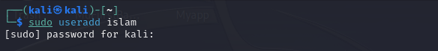Create a user account with the following attribute • username: islam • Fullname/comment: Islam Askar • Password: islam .
2. A screen shot of a computer

   Description automatically generatedCreate a user account with the following attribute • Username: baduser • Full name/comment: Bad User • Password: baduser.
3. Create a supplementary (Secondary) group called pgroup with group ID of 30000

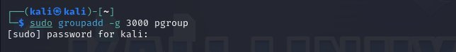

1. Create a supplementary group called badgroup
2. 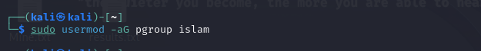Add islam user to the pgroup group as a supplementary group
3. Modify the password of islam's account to password

1. Modify islam's account so the password expires after 30 days



1. Lock bad user account so he can't log in

1. Delete bad user account
2. Delete the supplementary group called badgroupA blue screen with white text

   Description automatically generated